Chapter 7, Problem 23.

Consider the circuit in Fig. 7.103. Given that v_{o}(0) = 10 V, find v_{o} and v_{x}
for t >0.

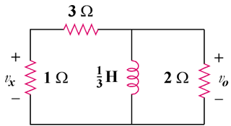

Figure 7.103
For Prob. 7.23.

